Red River Resistance
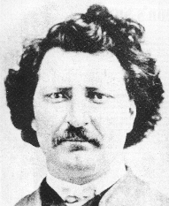
In 1885 Louis Riel was hanged for treason. In 1992, Prime Minister Brian Mulroney’s government declared Louis Riel a “Founder of Manitoba”. The conflict previously referred to as “The Red River Rebellion” in the past is now called “Red River Resistance”.

DO NOT ANSWER ON THIS SHEET. USE FULL, AND COMPLETE SENTENCES. USE EXAMPLES TO SUPPORT YOUR OPINION.
http://www.canadahistoryproject.ca/1870/1870-05-rr-rebellion.html
Horizons Text: pp. 155-168

1. What were the factors that led to the Red River resistance?
2. What was the motivation of those involved in the Red River resistance? (cause)
3. What were the key events of the Red River resistance? (the act)
4. What happened immediately after the Red River resistance? (the result of the act, deaths, injuries, damage…the consequences)
5. What were the long-term outcomes of the Red River resistance?
6. Did the end justify the means in the Red River resistance? (did the outcome make the act okay? Why?)
7. In your opinion, what long term impact did the Thomas Scott affair have on the relationship between Ontario, Quebec, and the rest of western Canada?

